

**Project:**

**Digital Clock using Logic Gate ICs.**

**Group Members:**

1. **Shozab Hussain (21k-3194) Leader**
2. **Yahya (21k-4895)**

**Course Instructure: Miss Sadaf Ayesha**

**Components Used:**

**1.IC 4026.**

**2.555 Timmer.**

**3.Resistors(47k,470,330).**

**4.7-Segment Display with common cathode.**

**5.Capacitor(4.7uF).**

**6.AND gate IC 7411(Three Inputs).**

**7. Breadboard**

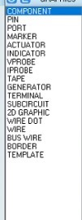

**Circuit Diagram**

